**CHAPTER ONE: INTRODUCTION**

**1.1 Background of the Project**

Churches play a vital role in the spiritual, social, and economic development of communities. For instance, in rural Sub-Saharan Africa, the church functions as a key social institution, contributing substantially to both spiritual life and socio-economic development [journals.spu.ac.ke](https://journals.spu.ac.ke/index.php/amjr/article/view/122?utm_source=chatgpt.com). Over the years, the management of church membership records, finances, and communications has largely been done manually. Paper-based systems such as handwritten registers and physical files are common and have been shown to be “prone to errors, loss, and inefficiencies” [Churches Admin](https://churchesadmin.com/blog/church-admin-system-kenya/?utm_source=chatgpt.com). These traditional methods are often time-consuming and limit how effectively churches communicate with their members.

In the modern digital age, churches increasingly require reliable systems to store, manage, and retrieve member information, facilitate effective communication, and ensure operational accountability. Church Management Systems or Church Admin Systems—now offer centralized member registration, attendance tracking, and donation recording, shifting away from manual record-keeping to automated, cloud-based platforms [Churches Admin+1](https://churchesadmin.com/blog/church-admin-system-kenya/?utm_source=chatgpt.com).

A Church Database and Communications System represents a vital tool to automate member registration, attendance tracking, financial contributions, and announcements. Such systems streamline administration and enhance communication between church leadership and congregants, fostering better engagement, transparency, and efficiency [Ministry Brands](https://www.ministrybrands.com/church-management/database?utm_source=chatgpt.com)[Churches Admin](https://churchesadmin.com/blog/church-management-system-4/?utm_source=chatgpt.com). This project aims to design such a system to improve church administration and enhance communication.

**1.2 Problem Statement**

Many churches face difficulties in managing large volumes of member data and effectively reaching out to their congregations. Manual record-keeping leads to data redundancy, inaccuracies, and loss of information. Additionally, passing information through verbal announcements or printed notices often results in missed communications, especially for members who are absent from services.  
The lack of a centralized and automated system creates challenges in decision-making, transparency, and accountability. Therefore, there is a need for a system that ensures proper record management, secure data storage, and reliable communication channels.

**1.3 Aim of the Project**

The main aim of this project is to develop a computerized Church Database and Communications System that will automate the storage and retrieval of member information, enhance communication, and improve administrative efficiency in church operations.

**1.4 Specific Project Objectives**

The specific objectives of the project are to:

1. Design a centralized database for managing church member information.
2. Develop features for tracking attendance, tithes, and offerings.
3. Provide secure login and role-based access for church administrators.
4. Implement a communication module for sending announcements via SMS, email, or in-app notifications.
5. Generate reports and statistics on membership growth, attendance trends, and financial contributions.
6. Ensure data security, backup, and easy retrieval of records.

**1.5 Scope of the Project**

The project will focus on developing a digital system that:

* Stores church member details (personal, family, and spiritual data).
* Tracks attendance and financial contributions.
* Facilitates communication through SMS, email, or notifications.
* Generates statistical and financial reports.  
  The system will not cover advanced financial accounting, live-streaming services, or integration with external platforms.

**1.6 Project Limitations**

The project is expected to face the following limitations:

* Limited budget for developing advanced features.
* Possible network connectivity challenges for communication modules.
* Users’ resistance to adapting from manual systems to digital platforms.
* Limited technical expertise among church administrators.

**1.7 Academic and Practical Relevance of the Project**

* **Academic Relevance:** The project will serve as a case study for applying database management, system analysis, and software development concepts in solving real-life problems. It contributes to the field of Information Technology and Management Information Systems.
* **Practical Relevance:** The system will improve church administration, enhance communication, reduce paperwork, and ensure accuracy in record-keeping.

**1.8 Beneficiaries of the Project**

The main beneficiaries of the project include:

* **Church Leaders:** Gain access to reliable reports for decision-making.
* **Church Administrators:** Save time and effort in managing records.
* **Church Members:** Receive timely communication and personalized engagement.
* **Researchers and Students:** Use the system as a reference for future projects.

**1.9 Project Activity Planning**

The project will follow the **Gantt Chart** and **Work Breakdown Structure (WBS)** project management tools. Activities include:

1. Requirement gathering and analysis.
2. System design (database schema and user interface).
3. System development (coding and integration).
4. System testing and debugging.
5. Deployment and user training.
6. Documentation and final reporting.

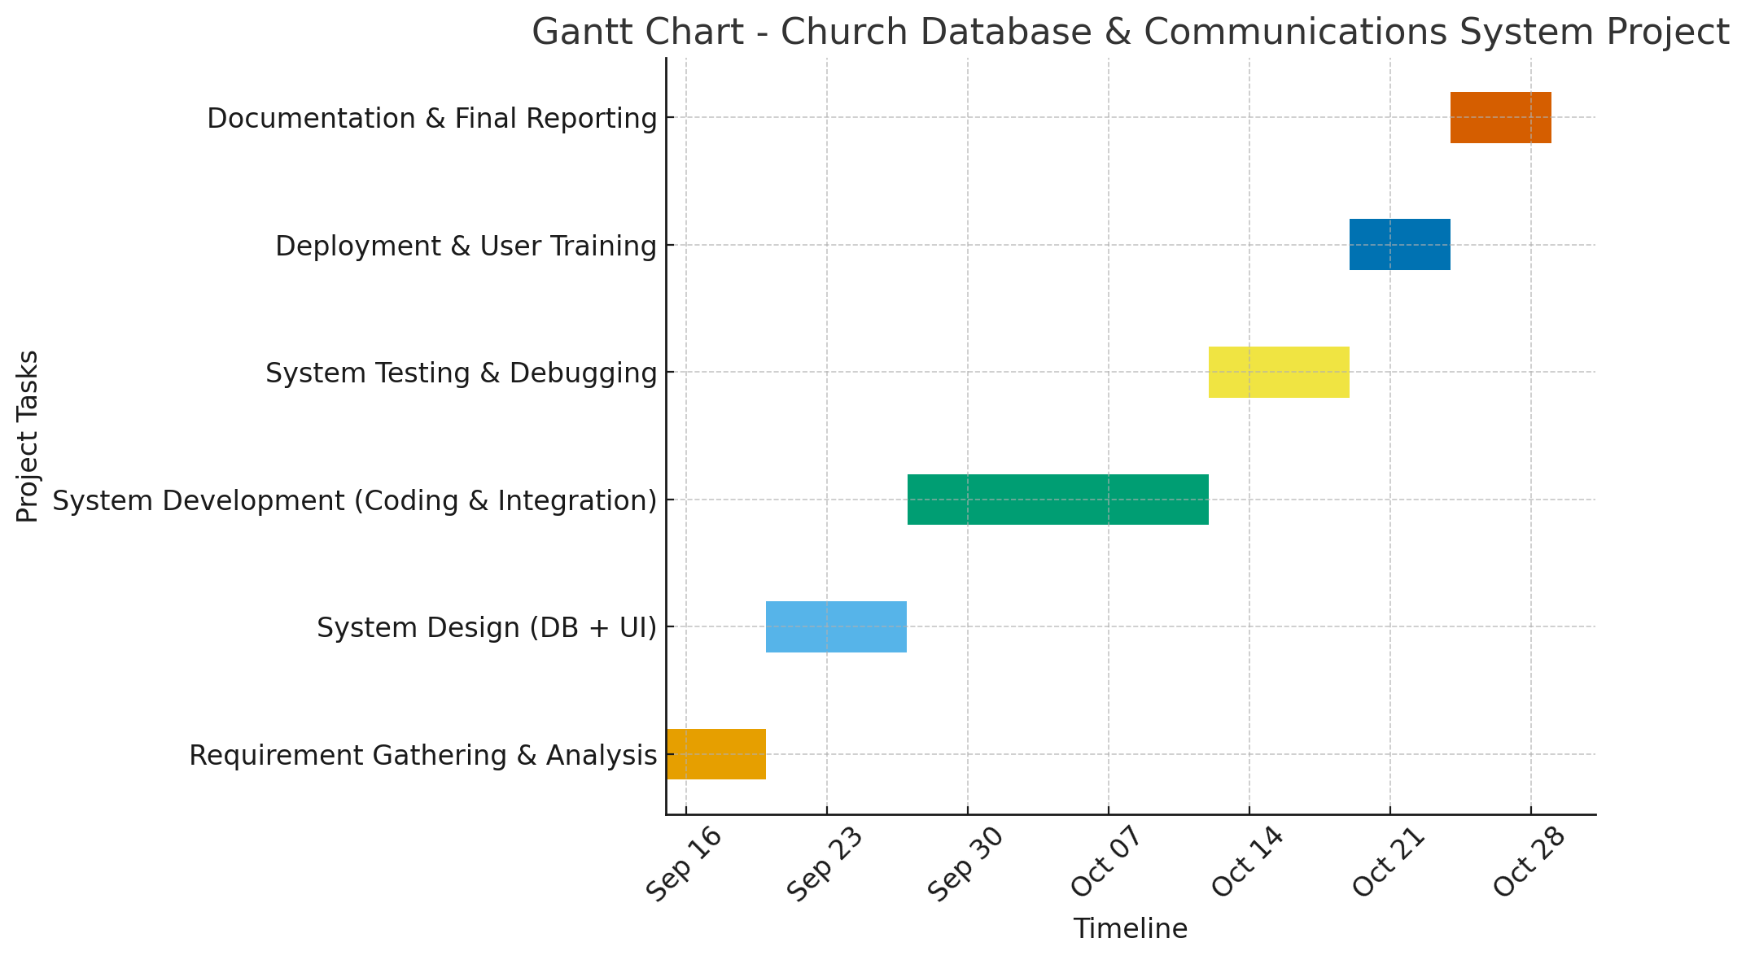

**1.10 Definitions and Explanations of Terms**

* **Database:** A structured collection of data stored electronically for easy access and retrieval.
* **Communication System:** A platform that enables the exchange of information between individuals or groups.
* **Automation:** The process of using technology to perform tasks with minimal human intervention.
* **SMS/Email Notification:** A feature that allows messages to be sent automatically to members’ phones or email addresses.

**1.11 Structure of Report**

The project report is organized as follows:

* **Chapter One:** Introduction – covers background, problem statement, and aim, objectives, scope, limitations, relevance, beneficiaries, planning, definitions, and report structure.
* **Chapter Two:** Literature Review – reviews related works, theories, and existing systems.
* **Chapter Three:** Methodology – explains the tools, techniques, and design approaches used.
* **Chapter Four:** System Analysis and Design – presents system requirements, architecture, and design diagrams.
* **Chapter Five:** System Implementation and Testing – details coding, testing, and validation of the system.
* **Chapter Six:** Summary, Conclusion, and Recommendations.